Vivian Hamby
Mr. A
Animation/VR
10/1/26
Unity 2D Skill Documentation
Step 1:
First, you will need to open your Unity Project
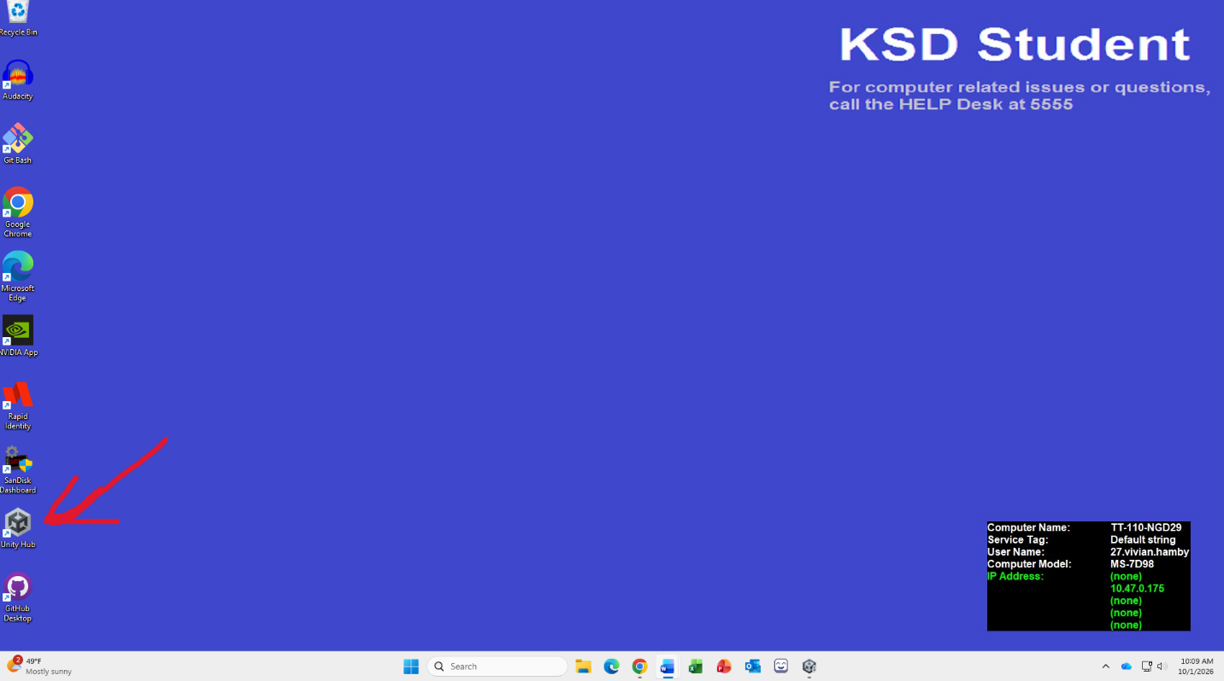

Step 2:
Go to the Scenes section in the Assets folder
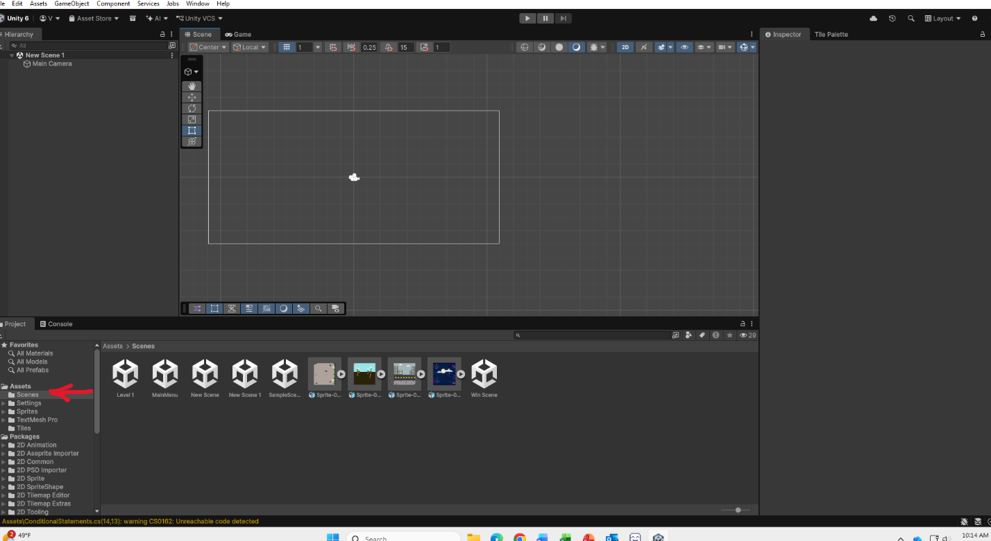

Step 3:
In the Scenes section, right click and the white option menu will pop up. Hover your mouse over Create as if you were making a new Mono Behavior script, then hover your mouse over Scene. Click on the Scene option. A new scene should appear. You can double click on the scene to open it.
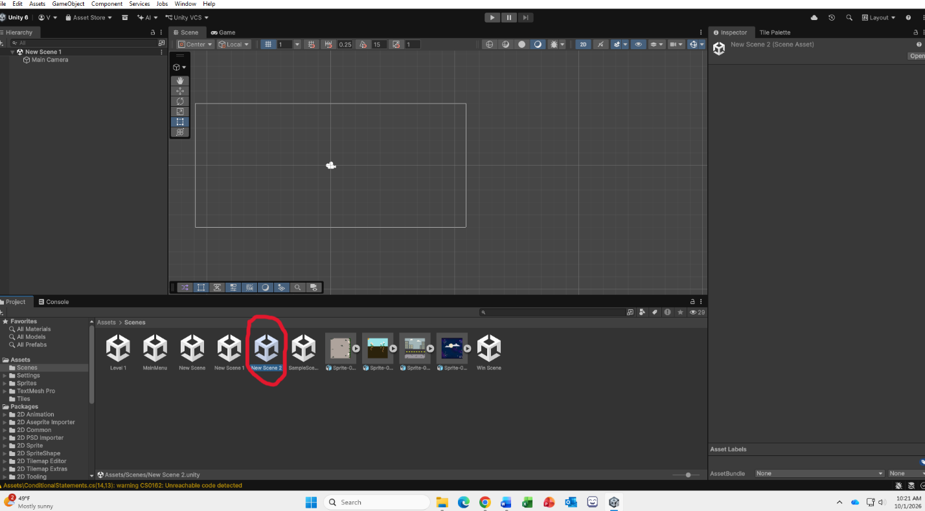
Step 4:
Once your scene is open, you can add your buttons. To do this, click to the plus symbol in the Hierarchy.
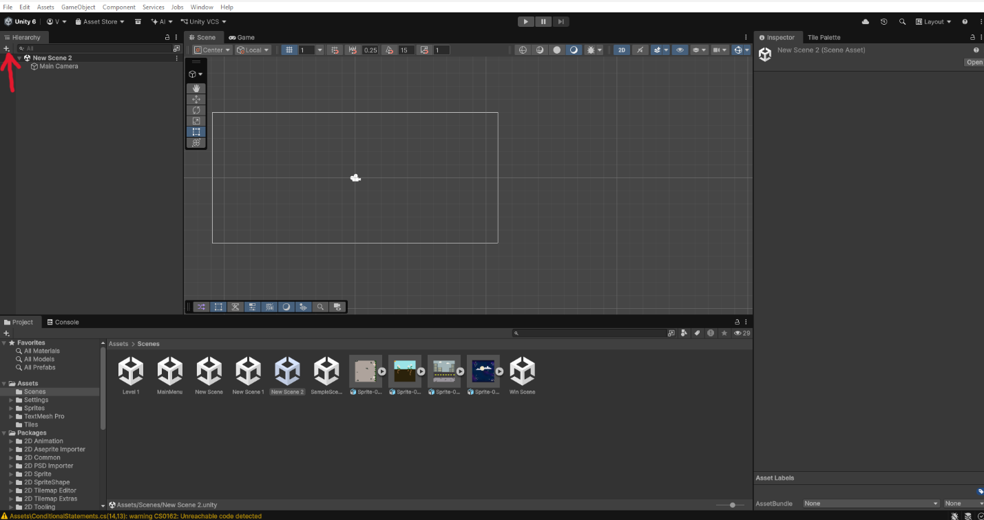

Step 5:
After clicking on the plus symbol, another white menu should pop up. Hover your mouse over UI(Canvas)
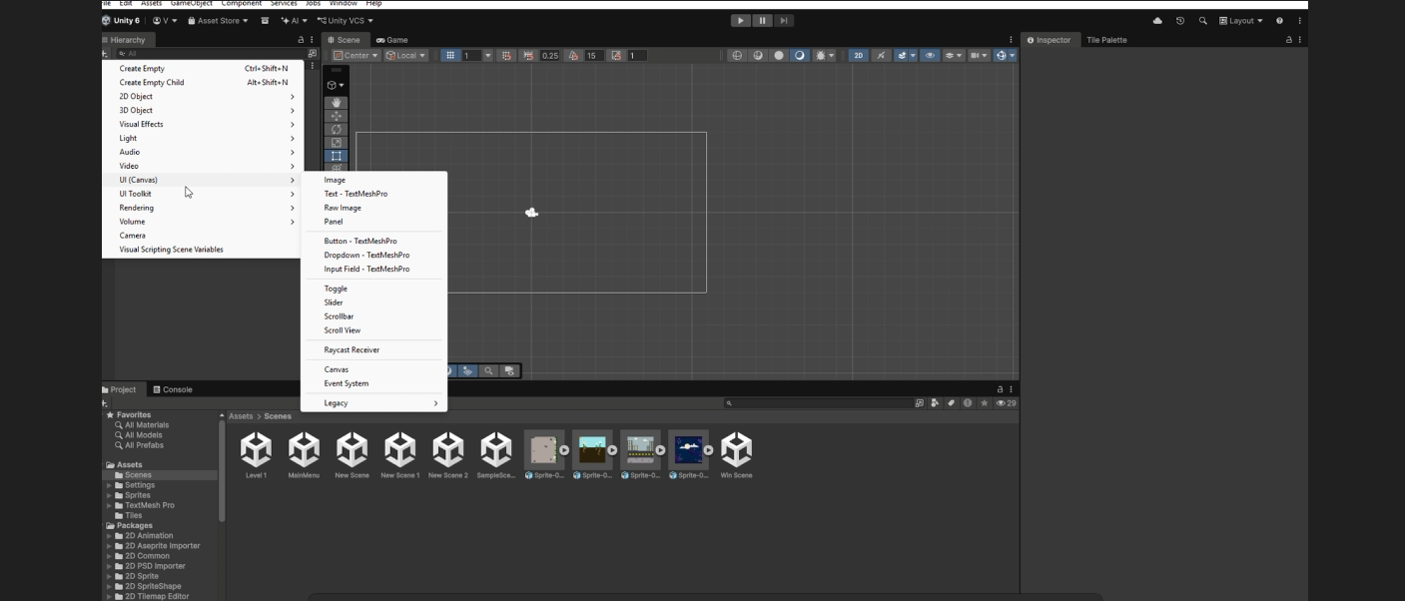

Step 6:
On the second white menu that pops up after hovering your mouse above UI(Canvas), click the Button- TextMeshPro option.
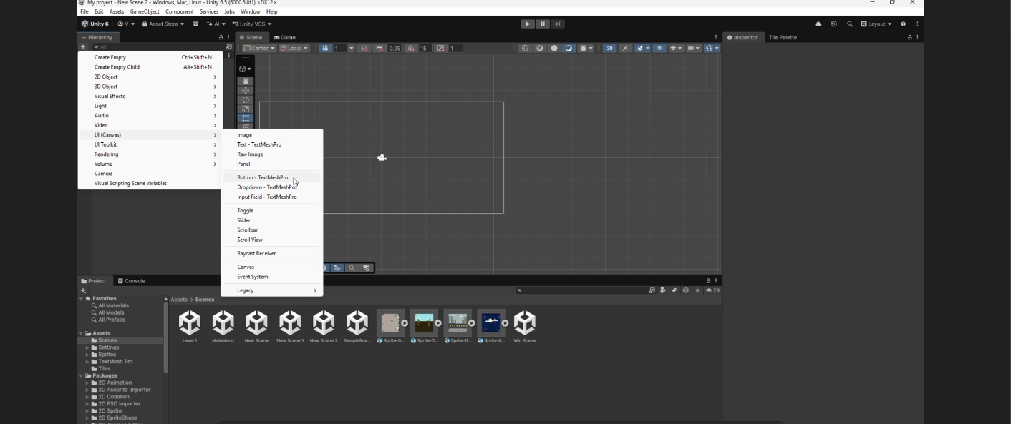

Congrats you made your first button! It should look like this right now:
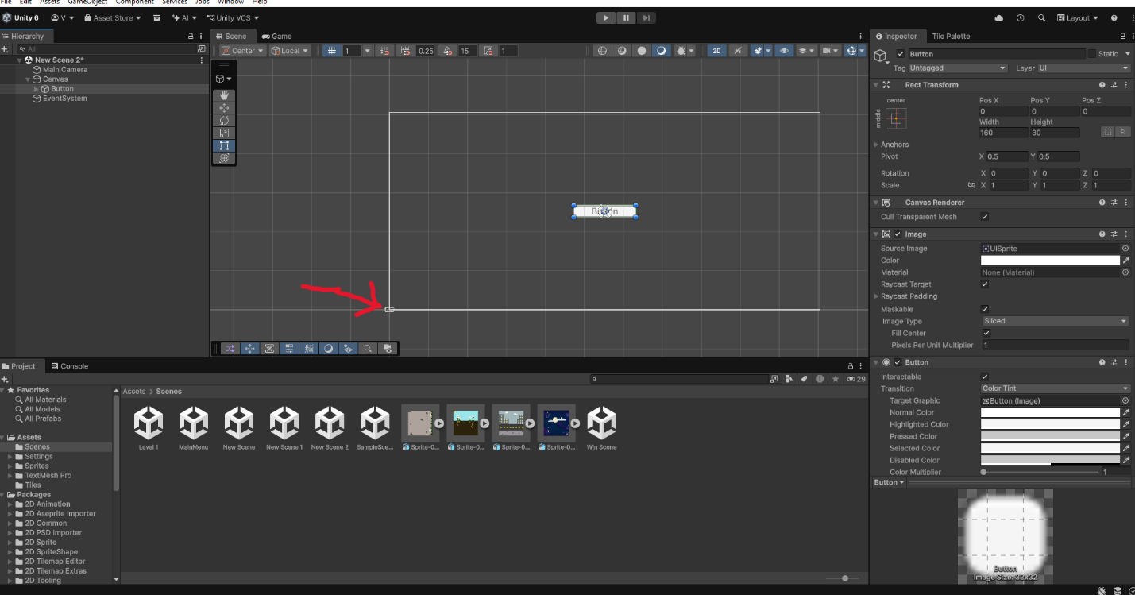

If it doesn’t make sure you’ve zoomed out enough, that tiny square at the corner? That’s where your camera is!

Step 7:
Now that you have your button, it’s important to name it so you won’t get mixed up when you eventually have multiple buttons on the same scene. You can do this by making sure your button is selected in the Hierarchy, then renaming it in the Inspector. This one will be named “Main Menu”.
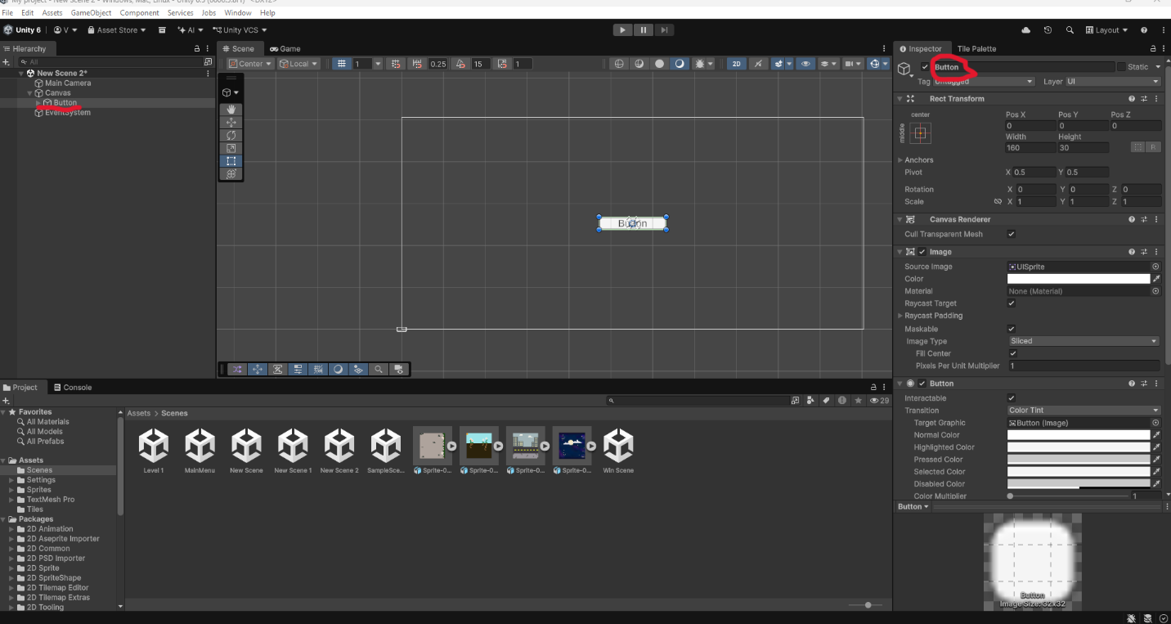

Step 8:
So you’ve renamed your button to “Main Menu” but it still says button on it? That’s because buttons are technically two things: the image and the text. We have changed the name of this pair. To change the text we have to open the main menu in the Hierarchy and in order to do this you can click on the triangle by the Main Menu in the Hierarchy.
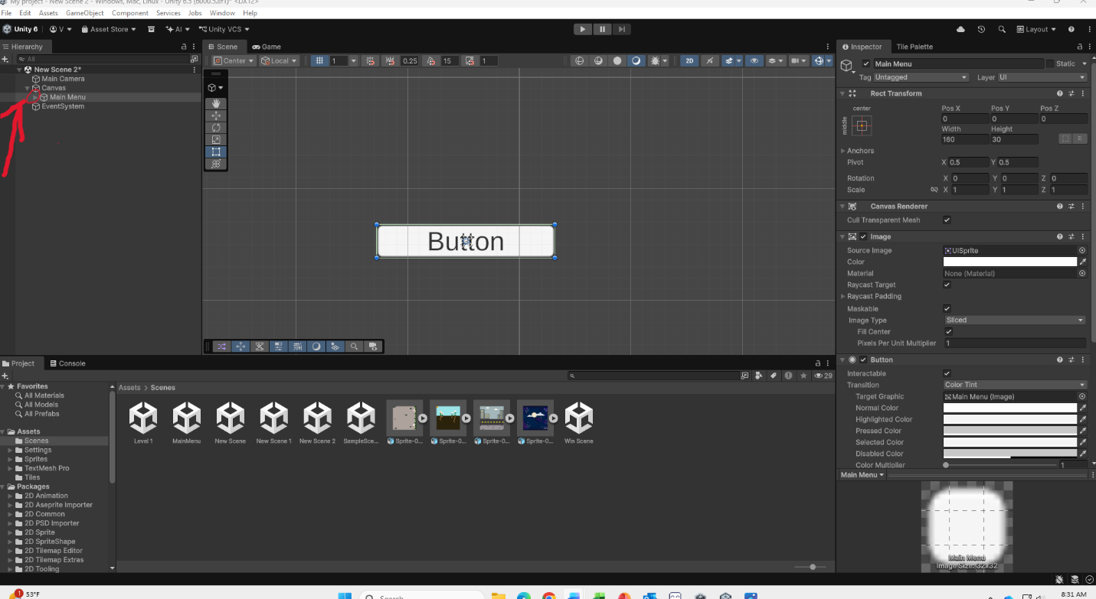

Step 9:
By clicking on the triangle, you should be able to now see the text object in the Hierarchy underneath Main Menu. Click on it to open the Inspector for the text.
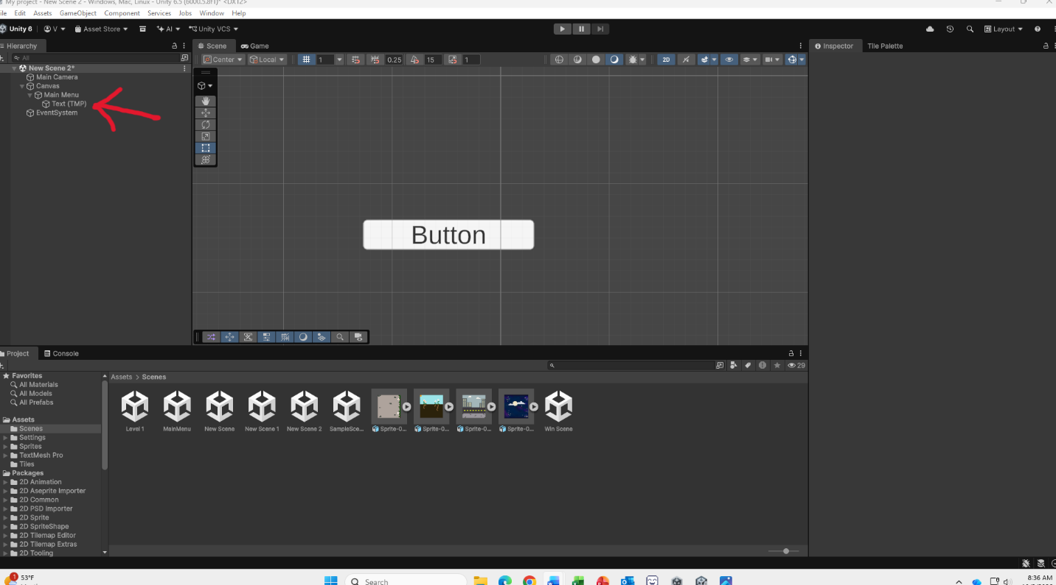

Step 10:
Now that the Inspector is open you should see a large box with the word “Button” inside. This is where you can change the text for your button. Change it to “Main Menu”.
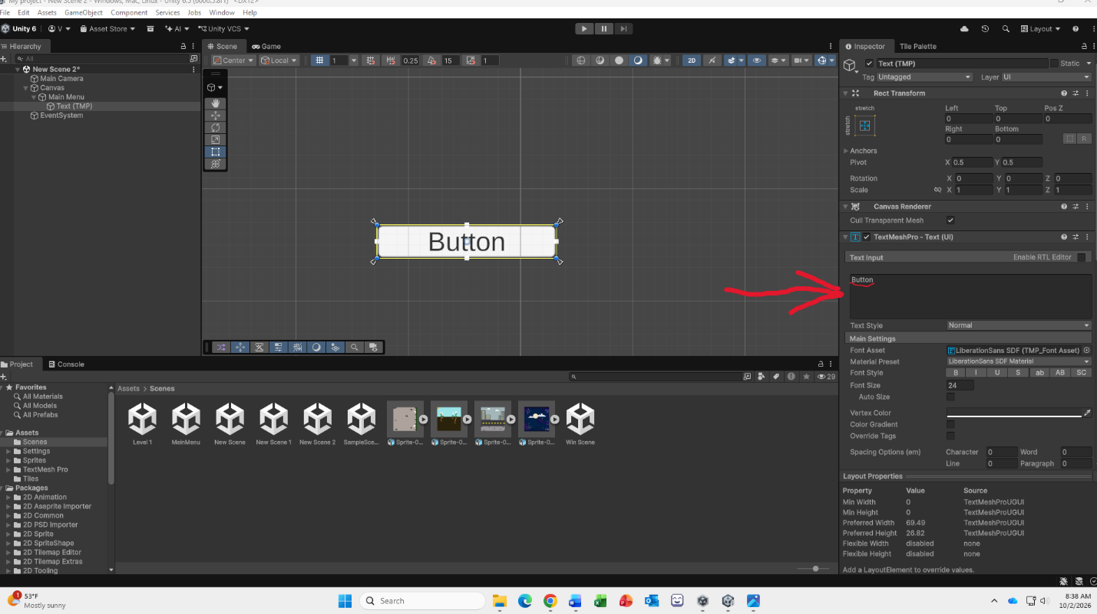

If you want to change how your button looks, you can click on the Main Menu object in the Hierarchy tab and go to the Inspector. Under Image you should see a white box across from the word “color”.
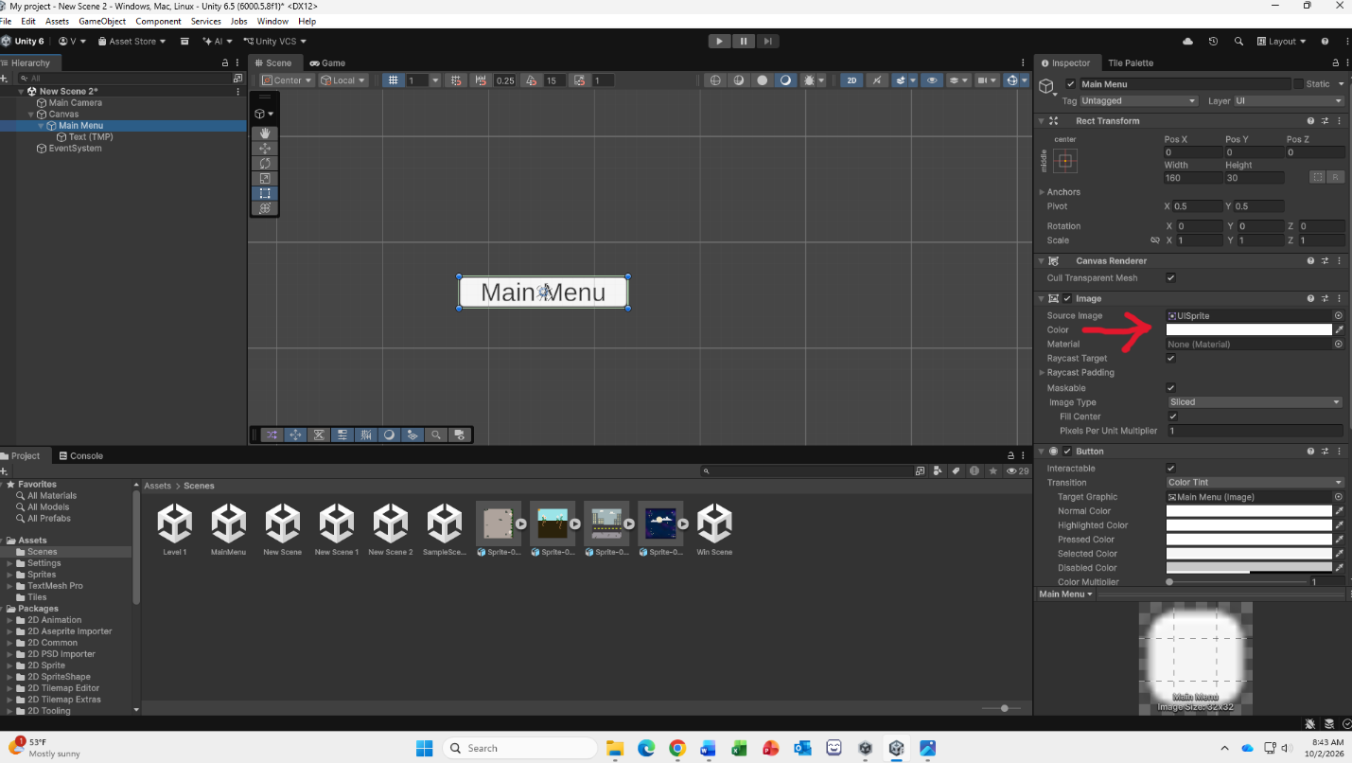

This white box shows you the color of your button. Click on it and a color wheel will appear that you can choose from.
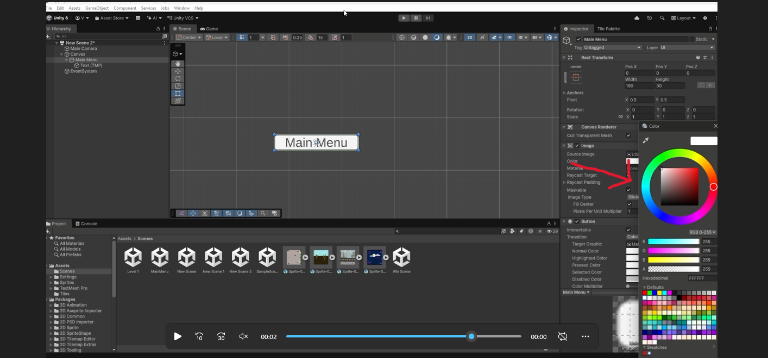
If you wish to have your button turn a different color when your mouse hovers over it, you can look lower on the inspector to the Button section. This section has multiple choices for when you want a color to appear on your button. For this you will want to choose “Highlighted Color”. Click on the white box and a color wheel should appear just like we did above.
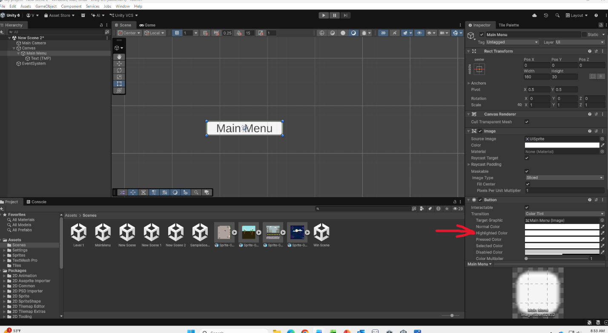

You are also able to have the color of your button change when it is pressed. To do this, click on the white box next to “Pressed Color”.
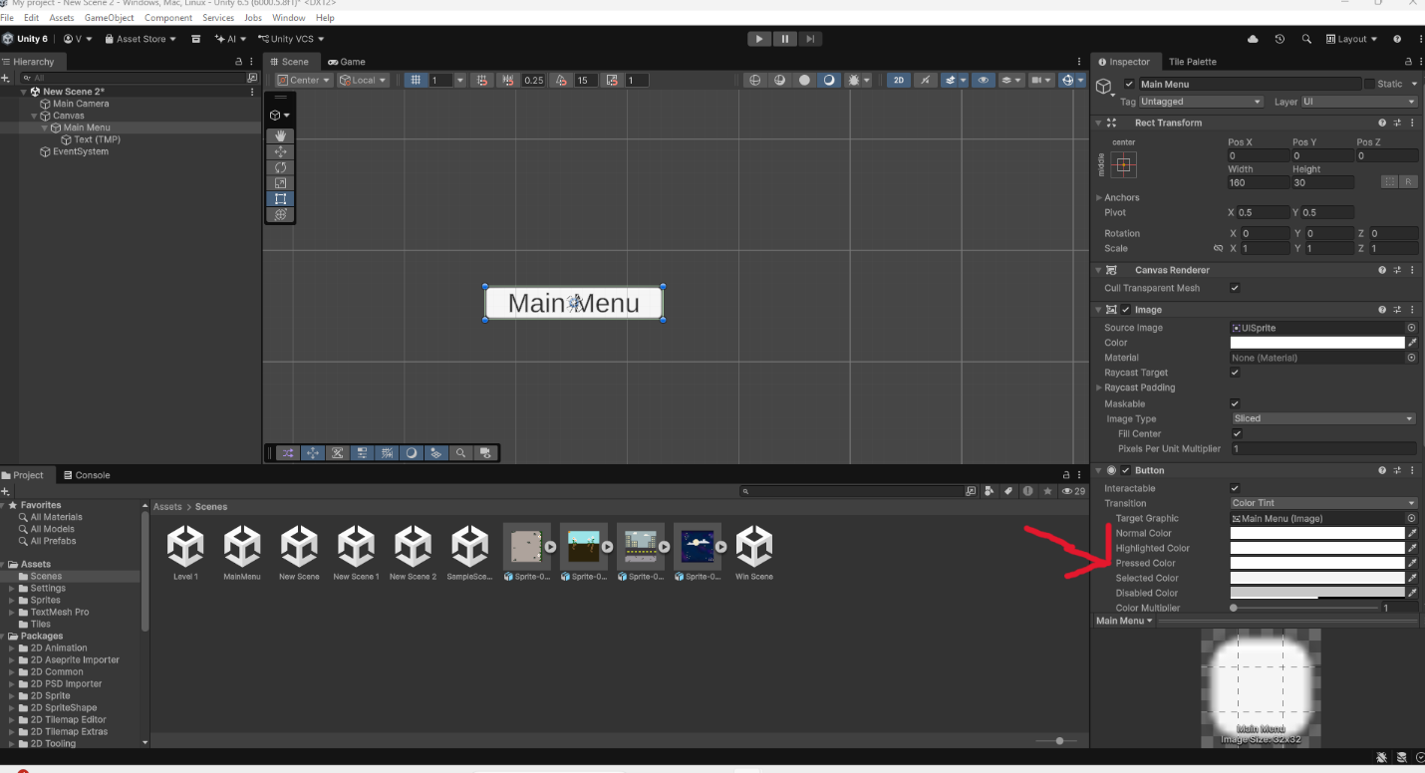

Underneath the color options for your button, there is also something called “Fade Duration”. This will change how long it takes for a button to change from its original color to the color chosen for when it is pressed.
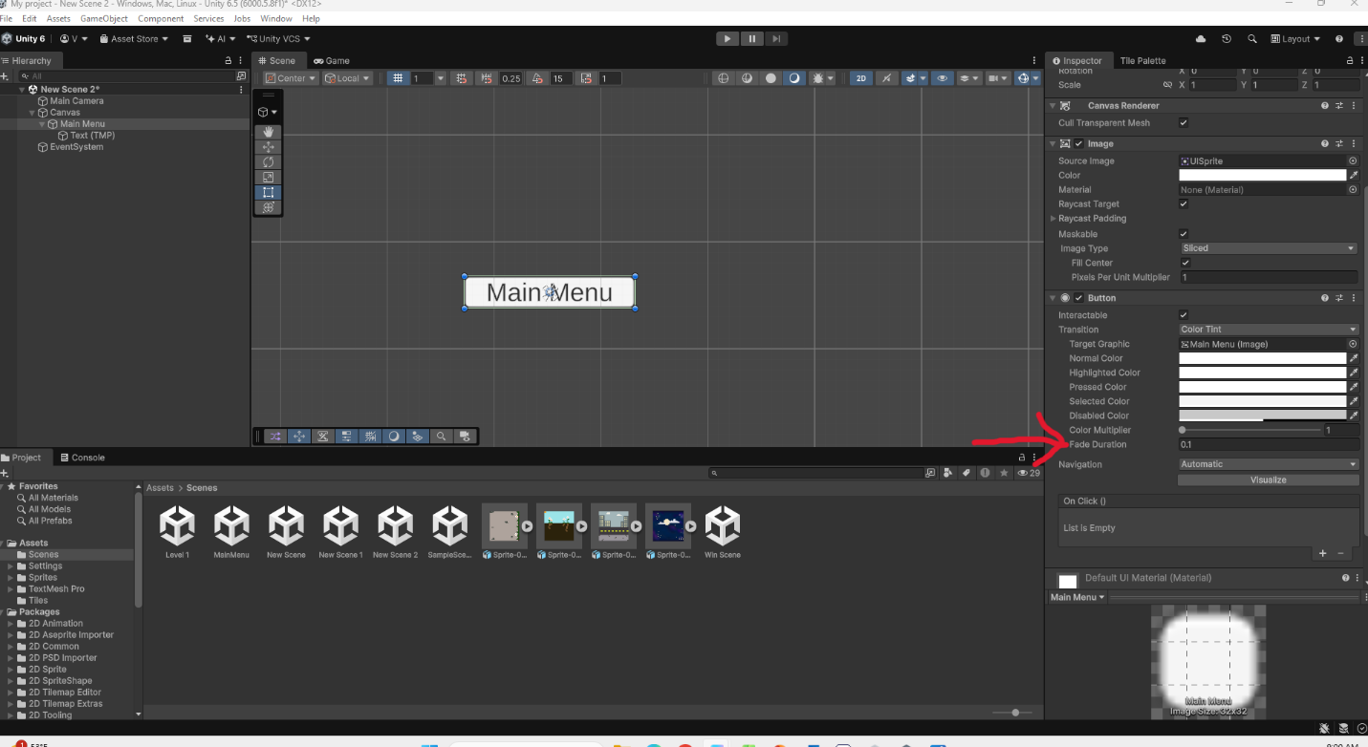
“Fade Duration” uses seconds to measure the time it takes to change. So, 0.1 = one tenths of a second.

Remember you won’t be able to see most of these color changes to your button unless you enter play mode first!

Step 11:
So, you have your button, and it interacts with your mouse how you want it to, now we have to actually make it to something!
We are going to make a new script for this so make sure you click on the Assets folder to get back to where you keep your scripts.
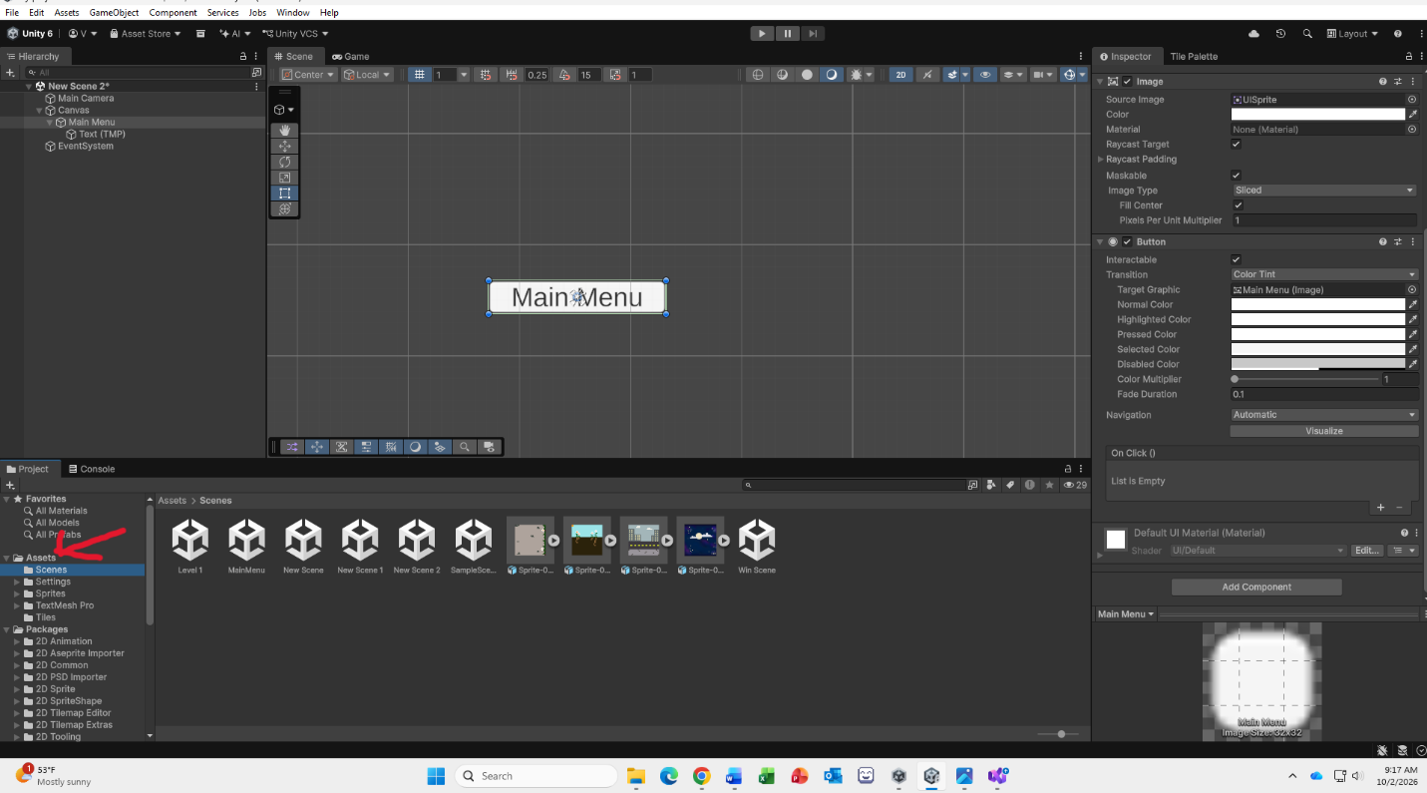
Now you can make a new script, which you should already know how to do. You can label it Menu.

Step 12:
In your script, you can delete Start and Update if you want to. If not start your code after Update.
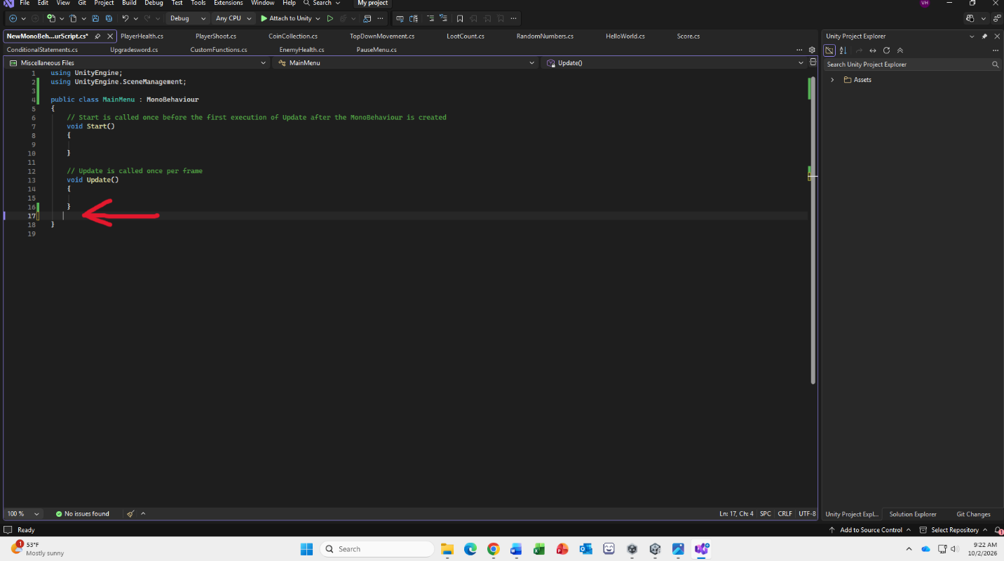
The first line of code we will write is a public void for our Main Menu which you can read in the screenshot below. Make sure to add the curly brackets at the end for our next line of code!
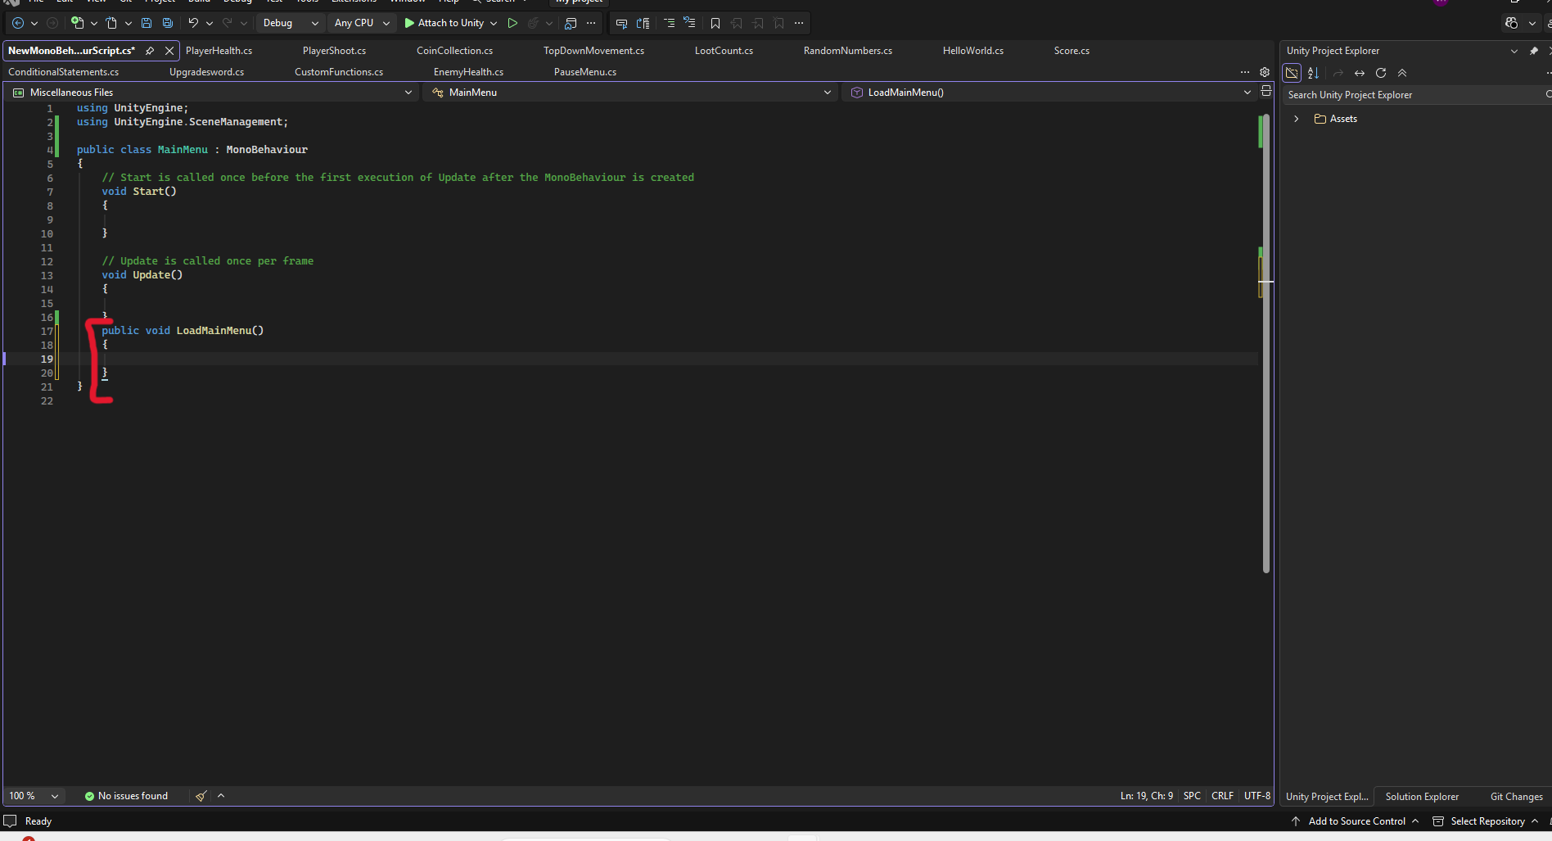
Now we have to actually load our scene in by using the Scene Manager. This line of code should be on the line between the curly brackets and will again be written in the screenshot for you to see.
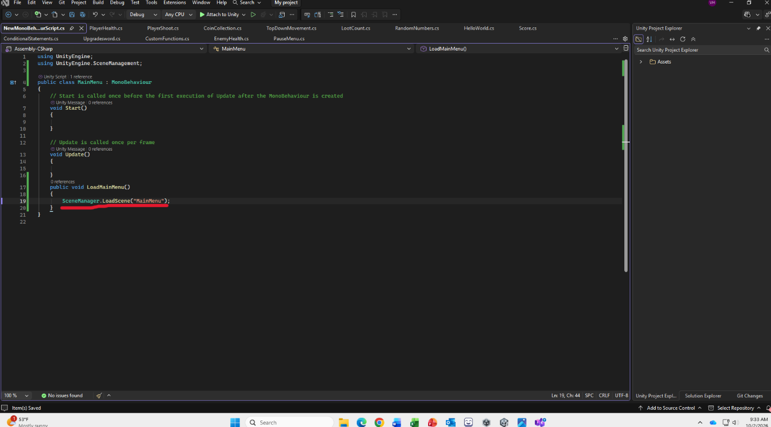
Make sure to save your script before you go back to Unity!

Step 13:
Now that we have our script written and saved, we can go back to Unity and put it in. Since this script is for our Main Menu button, that is what we will be putting the script on. Make sure the Main Menu object in the Hierarchy is selected so it’s Inspector is open. Scroll down to the bottom of the Button section of the Inspector and you should see a gray box titled “On Click()”. This box should say “List is Empty” inside of it.
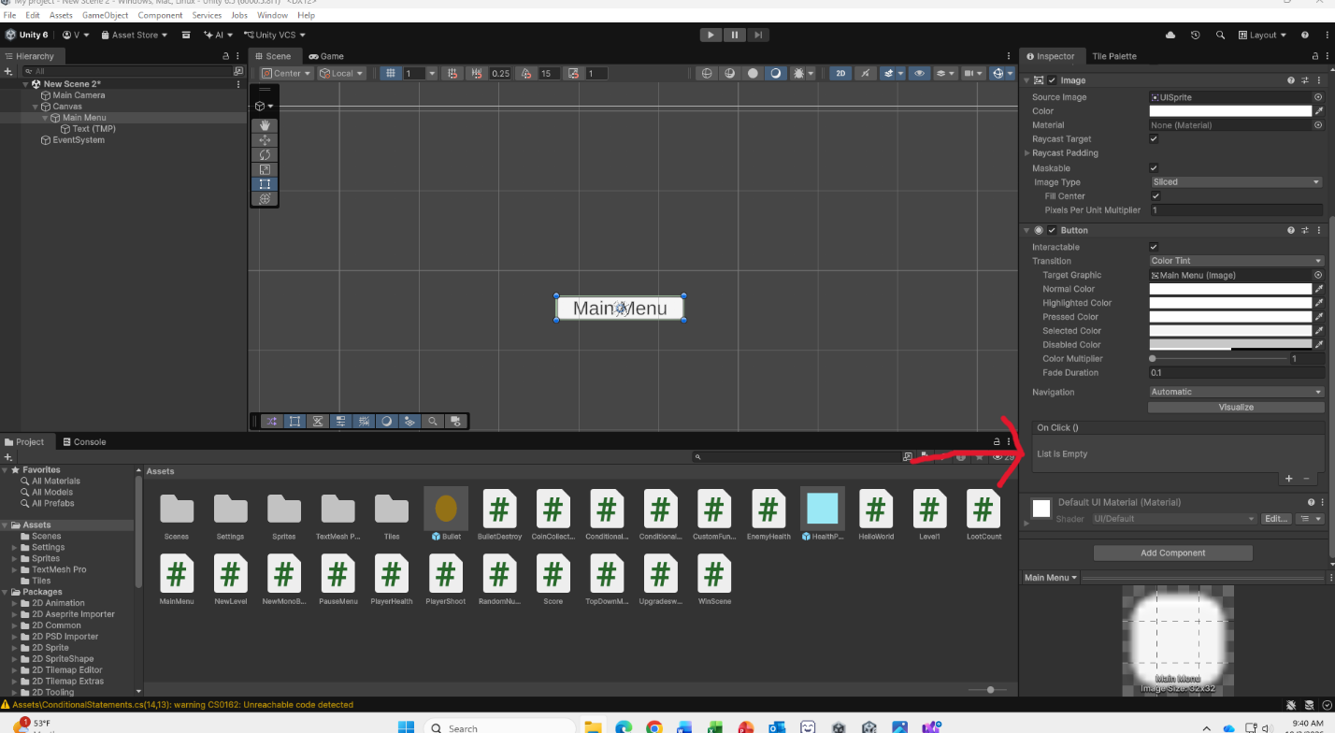

Click on the plus sign on the lower right corner of the “On Click()” box.
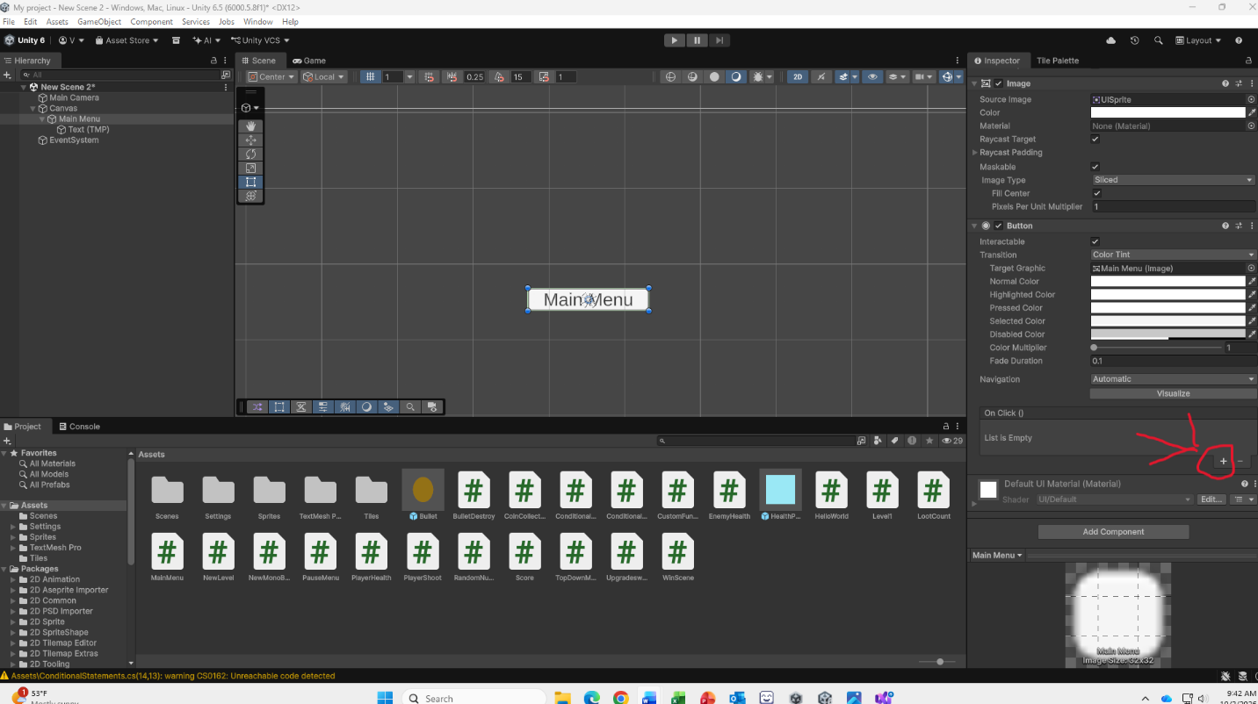

Now your “On Click()” box should look a little different, with three new boxes inside of it.
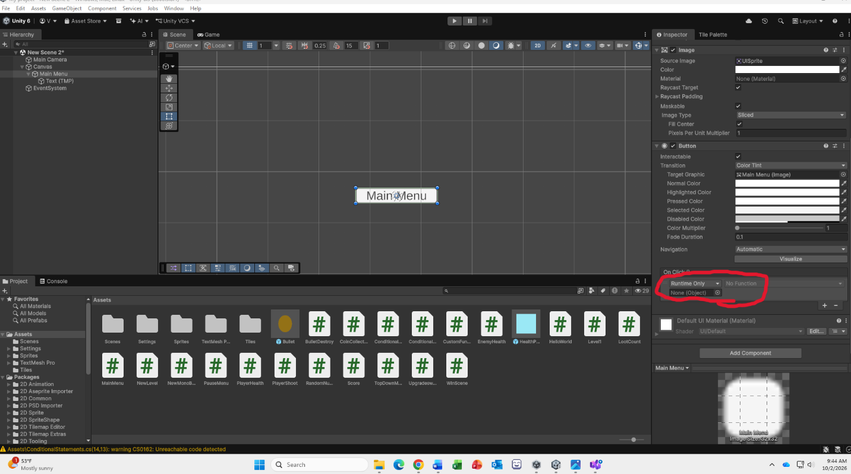
The first box we don’t need to do anything to, we want our button to only work when our game is running.
The box underneath of it should say “None(Object)” in it. This is because this is where our script goes. However, we can’t yet put our script directly from our Assets folder into it’s section and that is because it is a script and not an object.

Step 14:
Turn make our script an object that can be put into our “On Click()” box, we have to drag it from our Assets folder, into the Hierarchy. It should look like the screenshot below after you drag your script in.
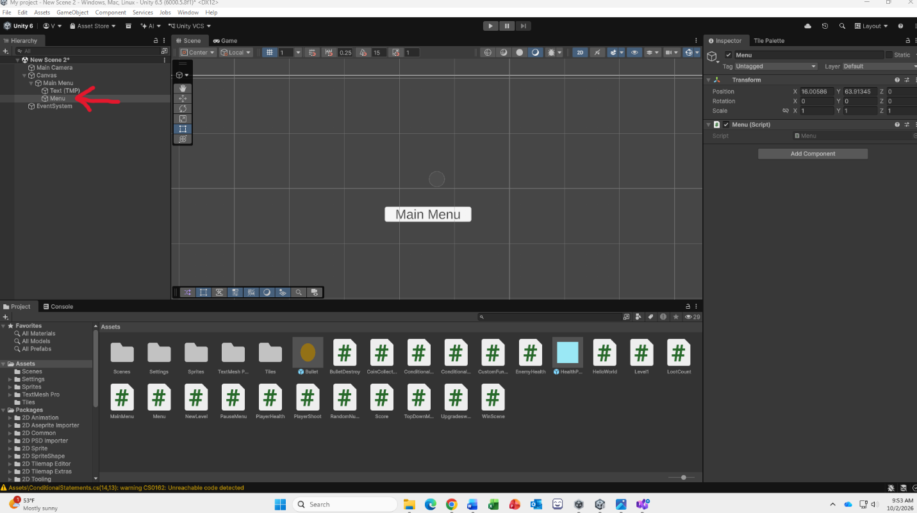

Step 15:
Now make sure you have reselected our button so its Inspector is open and we can see our OnClick() box.
From here, drag your script from the Hierarchy into the box that says “None(Object)” inside of the OnClick() box. The text inside should change to say “Menu” with a cube beside it.
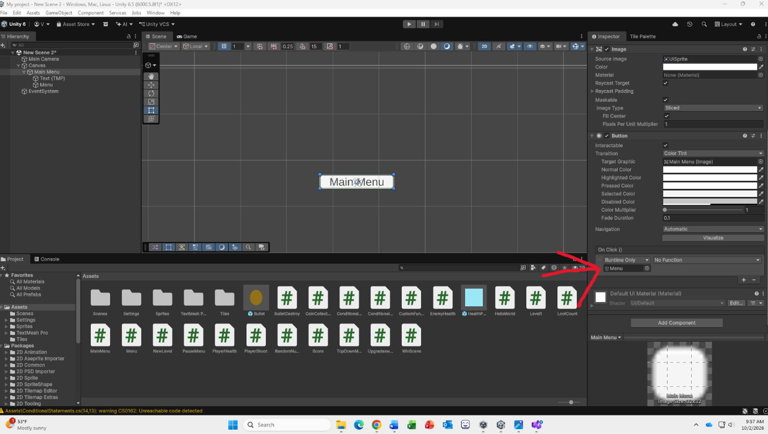

Now you are able to click on the third box in the OnCLick() box. It should no longer be grayed out but still say “No Function”. To select a function click on the small triangle at the end of the box.
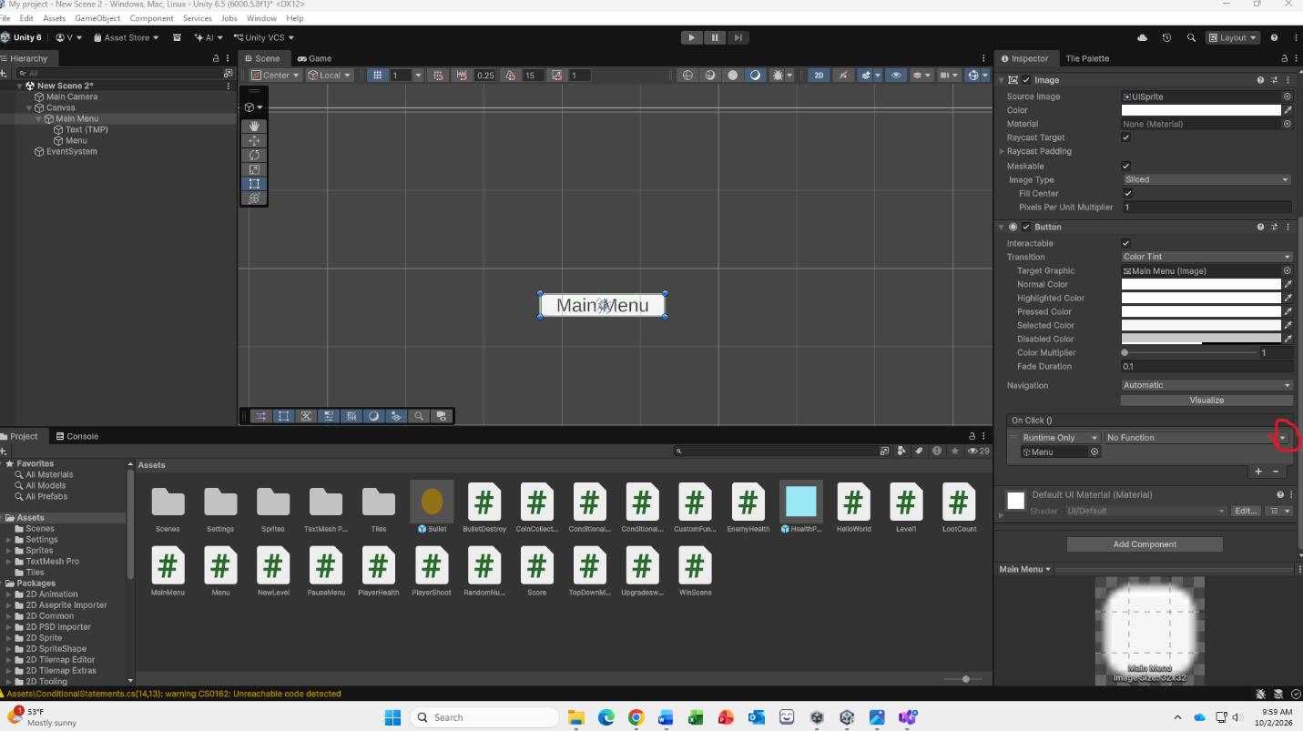
Clicking on the triangle should pop up a white menu, hover the option that says “Menu” at the bottom.
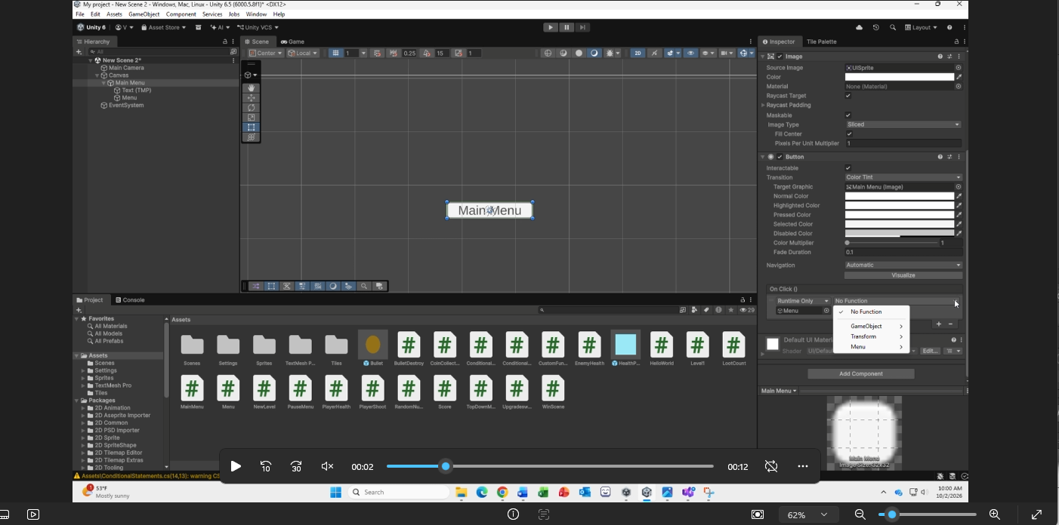
If you notice this is the name of our script!
Now you can see the second white pop up menu. You should be able to see an option that says “LoadMainMenu”, this is the script we just created. Click on it and it’s function will be added to our button.

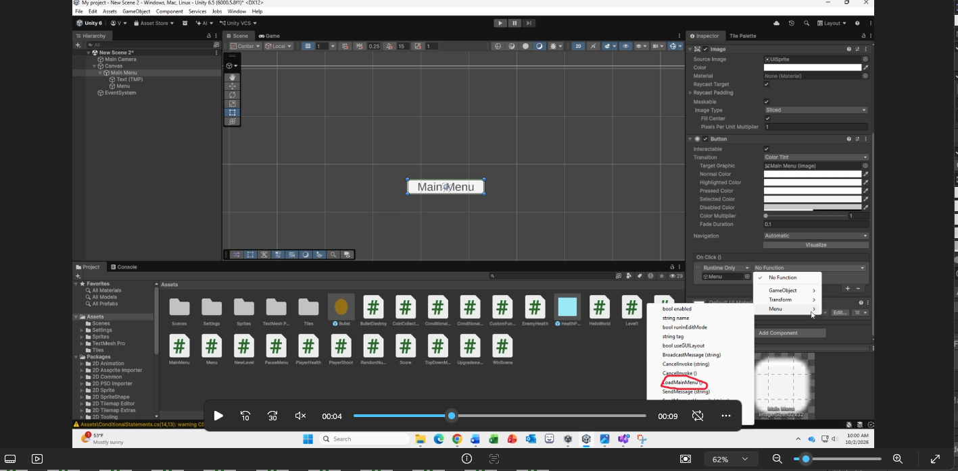

Step 16:
Before we can test our button, we have to actually create a scene for us to get taken to after pressing our button. To do this we will need a new scene. You can create one by going to the scene section of your Assets folder, right clicking and hovering over “Create”. From there you can hover over the Scene option and click “Scene”.
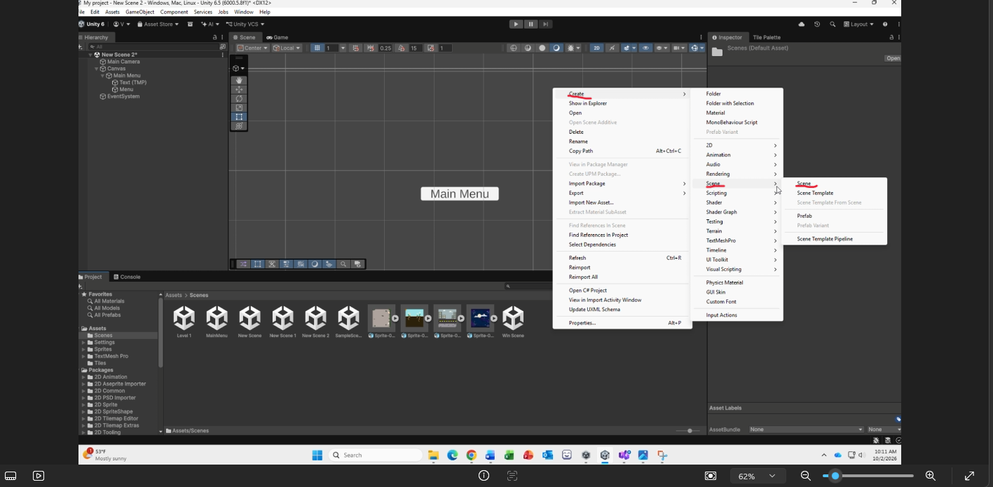
Make sure to label your new scene Main Menu!

Congratulations! You have successfully created a button that will take you to a new scene, enter play mode and make sure it works!

